**Iris_app Project Report**

* Create a new Django project and app. The project is called iris_project and the app is called iris_app; Then we need to Install required libraries: plotly and pandas;
* We define the Model for the Iris Dataset In iris_app/models.py.

* Create and Apply Migrations;
* Add 'iris_app' to the INSTALLED_APPS list in the settings.py file
* Import the Iris Dataset

Create Command Directory Structure: iris_app/management/commands/import_iris.py.

In import_iris.py, we define the command to import the dataset.

Then we run our management command to finish importing the dataset.

* Create the Visualizations in iris_app/views.py

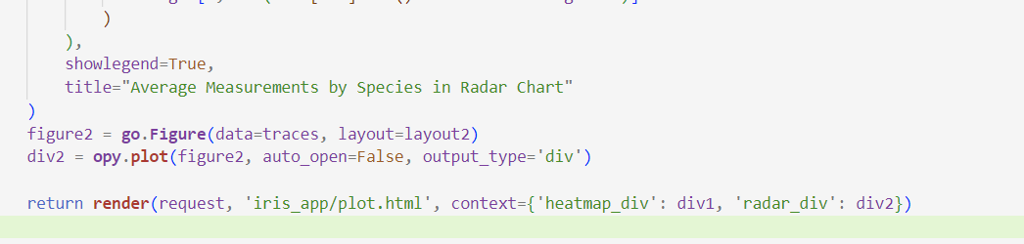

* Create the Template and html files under iris_app directory. iris_app/templates/iris_app/plot.html

* Update URLs in iris_project/urls.py

* Finally, run the Server:

